**SCRUM**

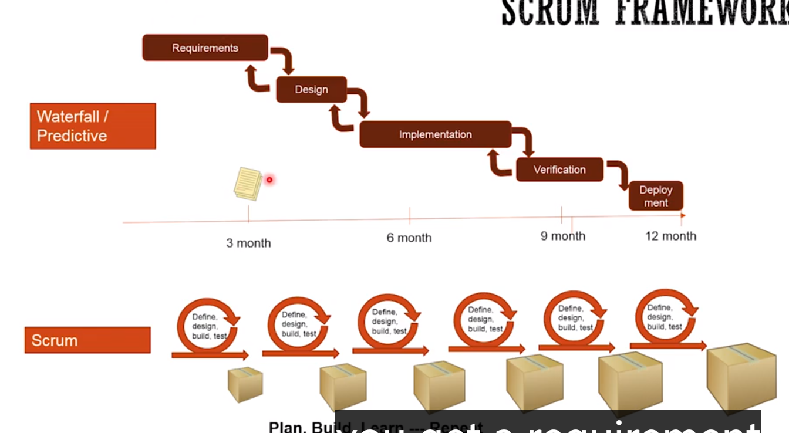

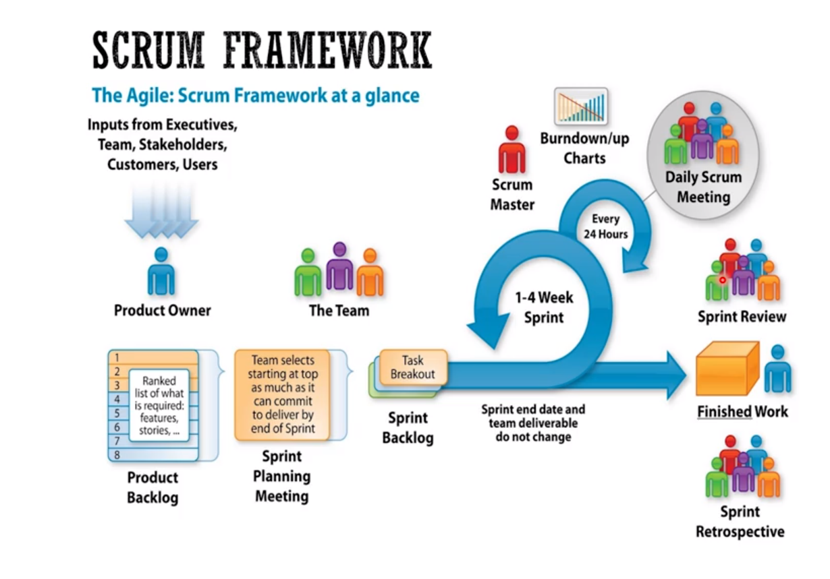

Product owner define what to be done in what order

Scrum master help team stayed true to scrum value and principles , has facilitate most meeting of the team. Deal with the road block, solutions

Team: self-organiztion do the most building of the software(dev test

1. SM =>What exactly need to be build => backlog a list of user stories prioritized define what need to be done => high level can change over time
2. Team => meeting sprint planning meeting whole team pick the top stories in existing sprint, PO review the sprint answer question => start working(designing) => start sprint

Daily meeting

1. Finish a product with some functionality sprint review
2. Another idea
3. Tweak function
4. How can we do better

So let's see how the job website will be created using a Scrum framework. So product owner is going to talk to the executives, the team, the stakeholders, clients, users, and we'll try to define what exactly need to be built. And so that will create something called a product backlog, which is basically a list of users to really which are prioritized and defines what need to be done. Now, the product backlog is very different than a typical requirements document. As you will see that, it's basically at very high level, and it can change over time. So very high level. In this case, it might mean that the first item might say post a job. So a company admin can post a job, or a job seeker can apply for a job. So those at that level, the back log is defined. So once the team is ready to sprint, they get together for a meeting called Sprint Planning Meeting, where the whole team gets together and then they pick the top stories that they can work on in the existing Sprint. And the product owner reviews those stories with the team and help answered any questions or clarifies anything that is not clear. And then the team gets together again and then do a tasking out of the stories, which means like, what exactly we need to do to build the software? So in this case, they may say, well, I need to design this database, I need to fill some data, attest data in the database. I need to create this UI screen. So once the team has looked at the stories, and they have tasked it out, and they know that they can finish it in the next sprint or the existing sprint, then they will come into the stories and say that, okay, we'll finish it in this sprint.

And then that starts their execution. That start the sprint where everybody is working to implement the software, and during that sprint, the whole team gets together for a daily standup, in which everybody talks about what they did yesterday, what are they going to do today, and if there are any road blocks. So in this case, a database person may say, well, I designed or created the tables yesterday in the database. And then today, I'm going to populate it with some test data, and if anybody out there who can help me, that will be awesome. And then he may also say that, I don't have the permission of certain things in the database, and unless I have that permission, I won't be able to finish my job. So then, somebody might help him like, who do I contact, and where do I go to get access to that? And so this thing continues for the rest of the days in the sprint, but at the end of the sprint, you end up having your finished product. In this case, it will be posting a job and then applying for a job. So let's say those were the two stories that were picked, so those two stories will be done at the end of the sprint. There are two other meetings that happened at the end of the sprint. The first one is called the sprint review, where the whole team gets together with the stakeholders, with the client, and demonstrate the work that they have done and get the feedback. So in that meeting, the stakeholders may say, well, I have additional idea, I think we should do that also. Or they may say that, let's tweak some of this functionality.

The second meeting that happens at the end of this sprint is called sprint retrospectives where they talk about the process and not about the product. So they talk about how can we do better? So in this case, they talk about what went well in the last sprint, what didn't go well in the last sprint, and how we can do better? So an example would be, well, nobody comes on time for the standup, and that results in not everybody get a chance to talk. So as an action item, we'll send a reminder like five minutes before the standup so that everybody can show up on time. And we can finish this stand up, and everybody gets a chance to talk.

To keep track of the sprint, are we going to achieve our goal for the sprint? Team uses something called a burndown or a burnup chart, which shows the amount of work left or the days of the sprint. So at any given day, they can say, are we going to make it, or are we not going to make it? And if they need to focus or need additional, [INAUDIBLE]. So that's it, that's the main key things about Scrum. So let's pause for a minute and see how Scrum actually supports Agile principles. As you can see, we are building intuitively, so it embraces change. After every sprint, you can make changes to your product backlog and shift your products to a different direction. It also supports a lot of meetings for collaboration, a lot of opportunities, I would say, for collaboration between the team members with the clients. And then, it also supports continuous improvement with the sprint retrospective, and there are many other things. But as we can see that, it at least embodies the key principles of Agile. To summarize, there are three roles in Scrum, Scrum master, the team and the product owner. There are couple rituals, like Sprint Planning Meeting, Daily Scrum Meeting, Sprint Review, and a Sprint Retrospective. And there are some artifacts like product backlog, sprint backlog, and burndown chart.

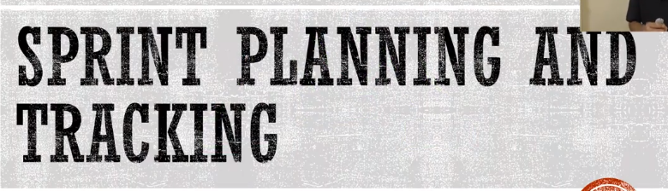

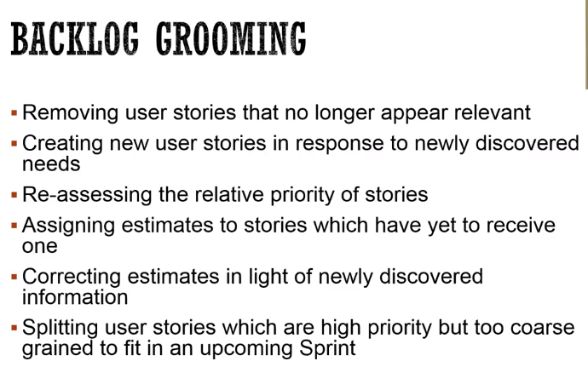

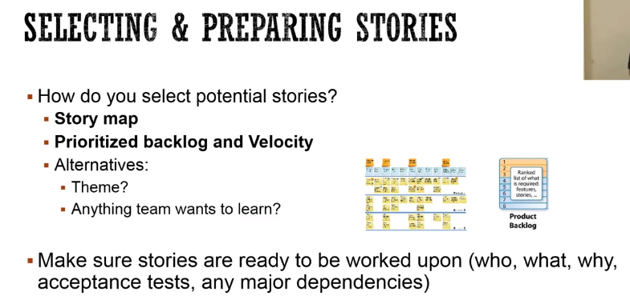

where the sprint planning is happening and then, the burndown in a chart which are used to track sprint.

 So, to do that, there's something called backlog grooming, or sometimes people call it backlog refinement that needs to happen. And so in this session, however you want to do it, whether in a meeting or you try to remove all the user stories that are not needed. You'll create news stories, or you assess the priorities of the stories, you update the priority, and then, if there are any estimates missing, then you give that estimate, and if there are estimate that needs to be updated, then you update those.  So, you want to make sure that your backlog is up-to-date

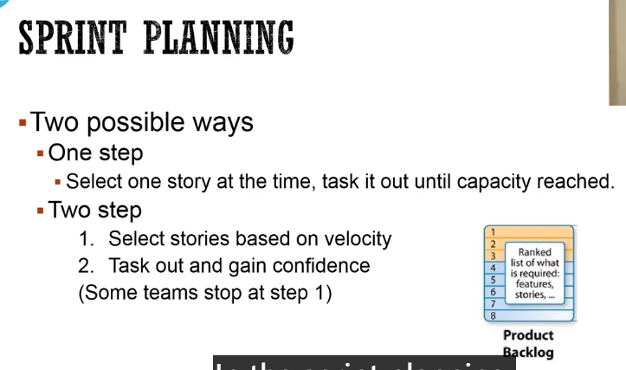

 How do you select potential stories for a sprint? You can either use the story map and just say, okay, this is the area that we are going to work on in the next sprint. Or you can use your prioritized backlog and just start from the top and just pick stories based on your velocity. The alternative is sometimes people select here is the one area we are going to focus on, or sometimes if you want to learn something, then they dedicate the whole sprint to that particular topic.

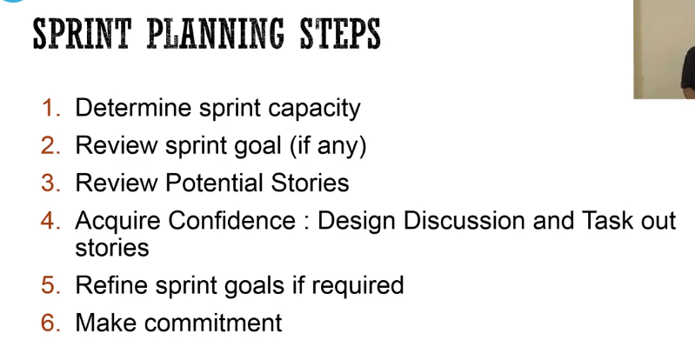

 In the sprint planning, you can do two possible ways. One is in the one step where you just go from the top of your backlog, take one story from the top, task it out and say, if my capacity is not reached, then you take the next story, and you keep doing that until your capacity is reached, or you can do a two step process where based on your velocity from last sprints, you select the story based on your predictive velocity for the current sprint and then you take those stories and then you task it out and validate that you can actually come into those stories.

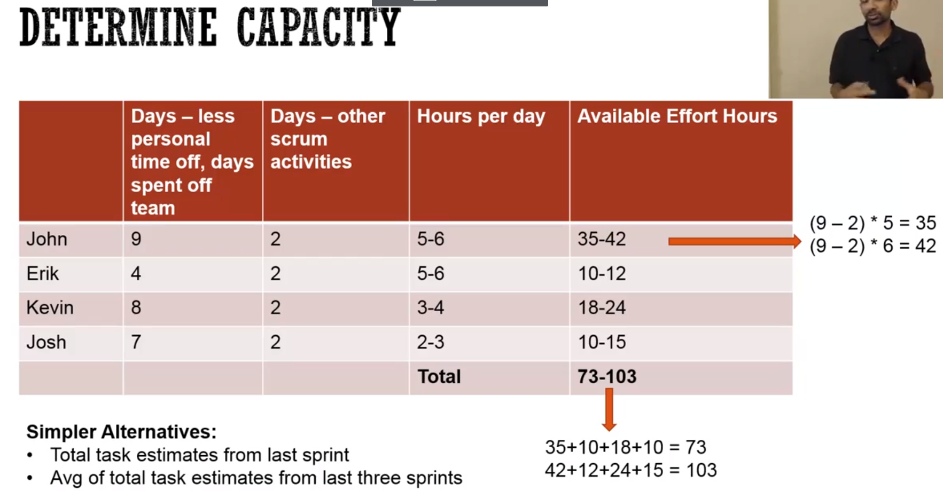

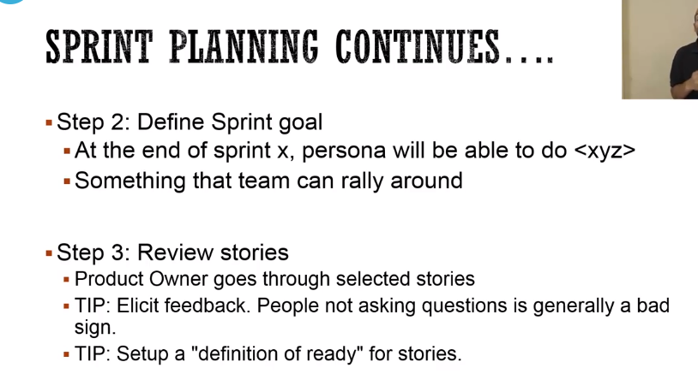

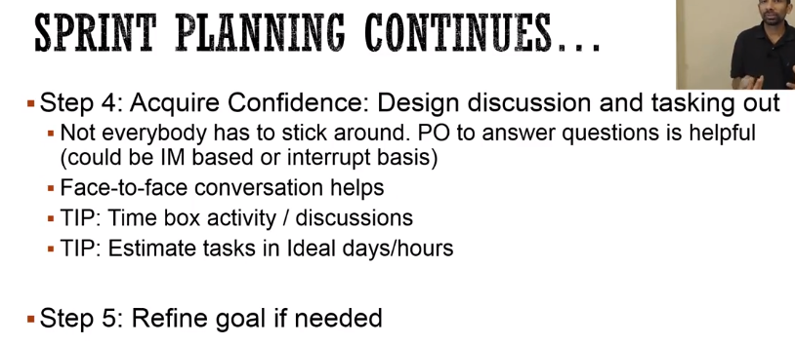

 So the product owner go to the story and explain everything, what is going to happen in the story. Now, during this part, if the people or the developers or the team members are not asking question, has to make effort to make sure that they are talking, and they are asking question. If nobody is asking question, it's generally a bad sign. And then you should also set up a definition of ready for the stories which means, is it ready to be worked upon?

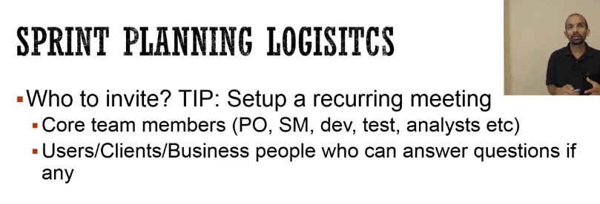

Now, some of the logistics about sprint planning. Who to invite? Well, of course, all the core team members. But you can invite all the users or clients or business, anybody who can help answer questions if any.

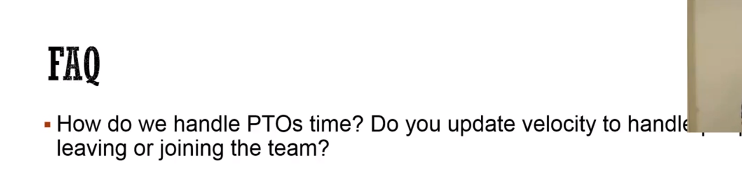

It depends quite a bit on preparedness of the sprint stories, the team maturity. But the general guidelines that it takes about four hours for a two-week sprint including the tasking out. Again like I said, then it depends on your preparedness.



The answer is generally no, unless the people are going in bulk. Like, for example, in holidays a lot of people are going. So, in that case, you may want to update it. But in most cases, it's taken care of and generally you use the capacity to come in. So, that optimally take care of the PTOs and who is available. How do you handle interruptions? So, let's say you are in the middle of the sprint, and somebody says, "Oh, this is really, really important and CEO want this to get done." . So, generally the idea is to let your product owner know and let the product owner decide if this should be part of the sprint or not.



 But generally if there are defects, the team will not be able to do the other stories, so their velocity will go down, and the next sprint they will ultimately take less work to start with. So, my recommendation is not to estimate defects. Either the team will reduce the number of defects or their velocity is going to go down, and they will take less work.

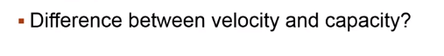

 So, velocity is based on the story sizes whereas capacity is what we calculate based on the availability of hours and days of individual team members.



One of the tip I give to people or teams is that you should always take one or two stories, very simple stories, to finish by the end of iteration zero. So, even though the main focus is to setup the continuous integration server and your workstations, but then it provides focus to finish something by the iteration zero.

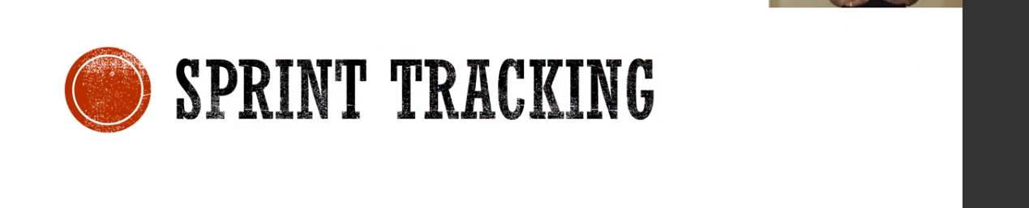

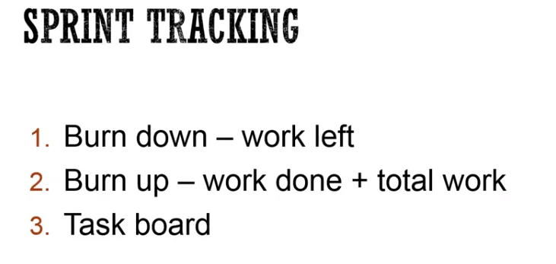

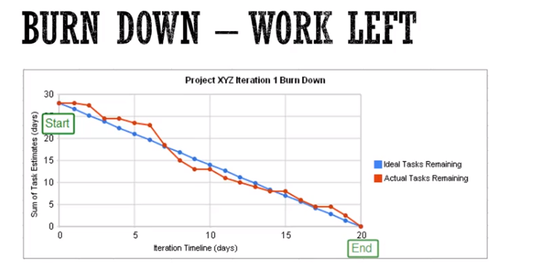

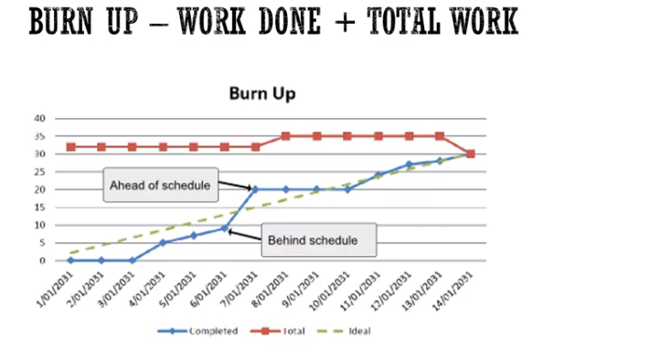

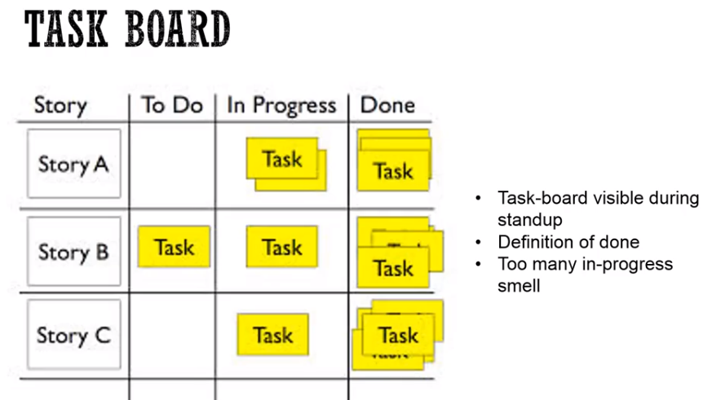

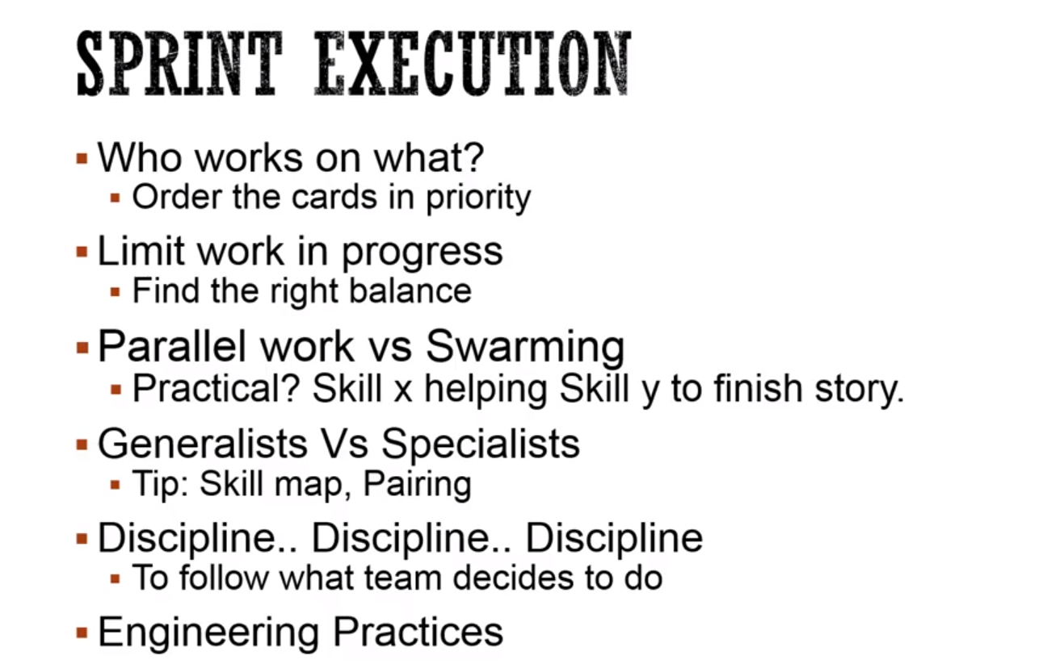

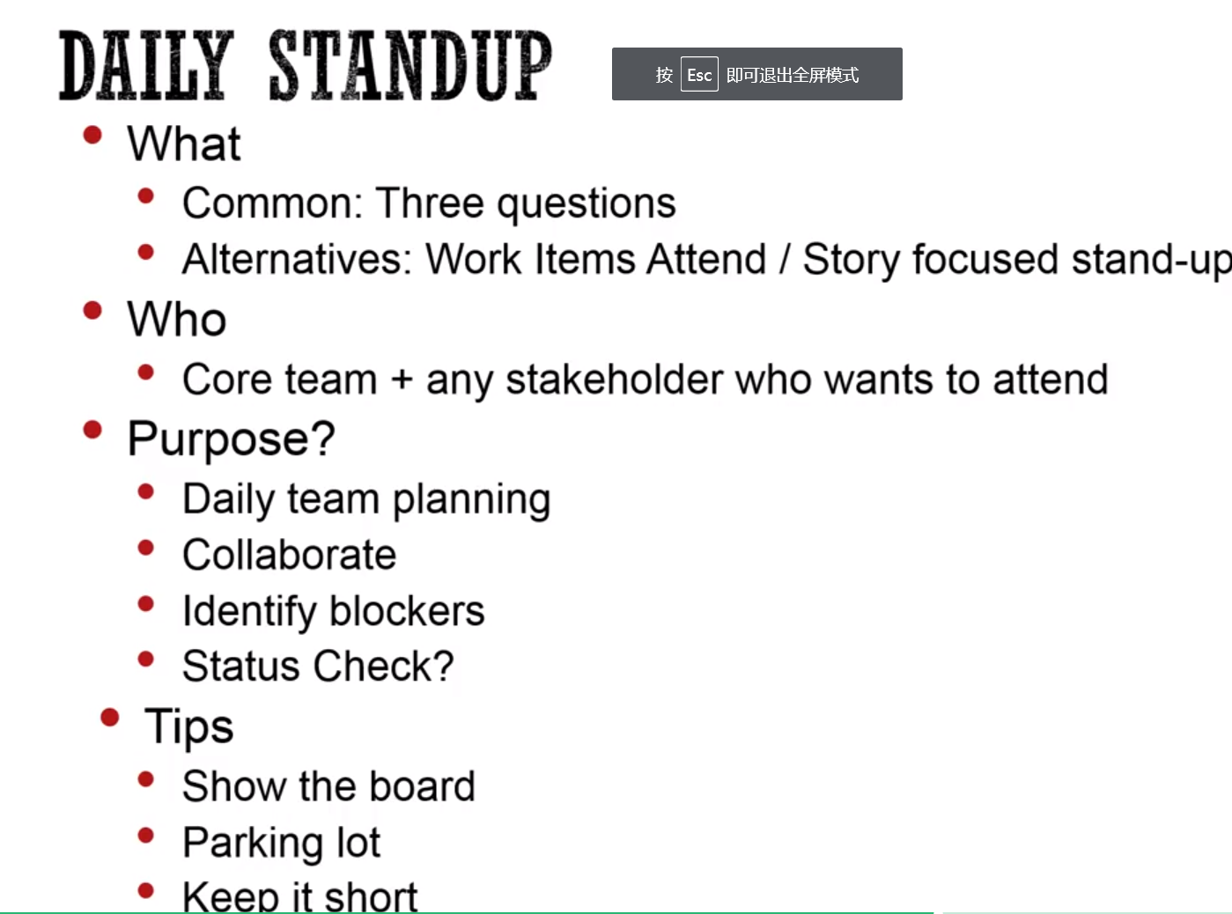

 it's recommended that the team members pick the work from the board rather than the work assigned to them.

Again, it depends on how many team members are there in your team, but you want to minimize the work in progress. And to do that, these two concepts will help. First one is instead of too many parallel work going on, use swarming, where you pick one story and then have everybody focused on that one. One of the problem is that you have a team member who has skill Y but you need skill X for that work, and so, the skill Y person has to help with the skill X. Sometimes, it's possible, sometimes, it's not possible. The second thing is, if you have too many specialists, then also, it becomes not possible to have those kind of swarming. So, you want to create generalists and to do that, sometimes pairing helps, so two people working together.

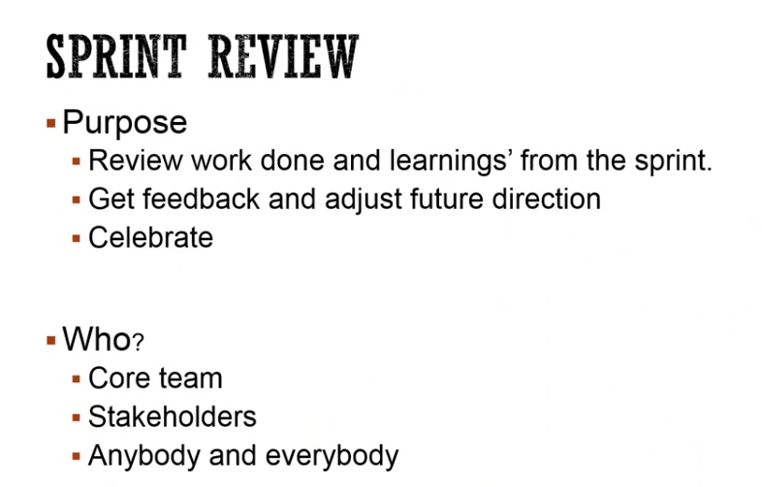

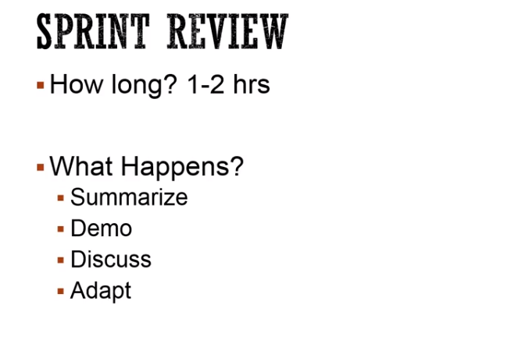

Constantly improve the process

All team memebers

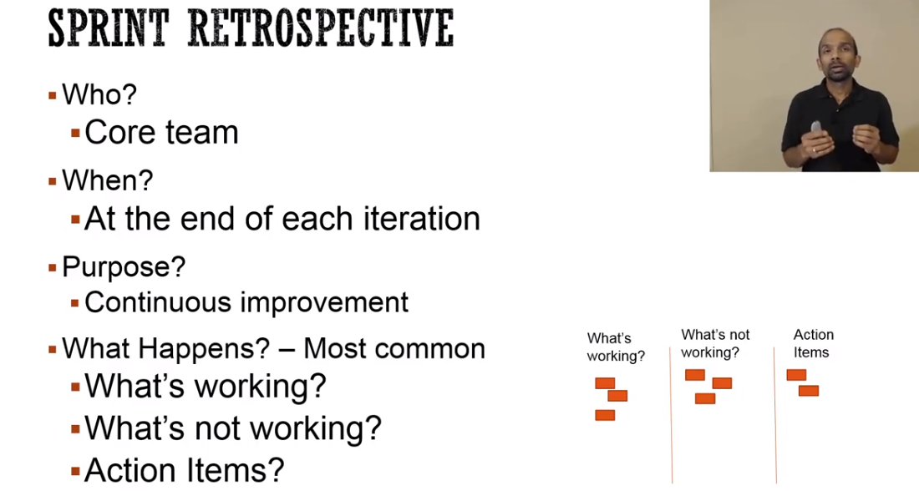

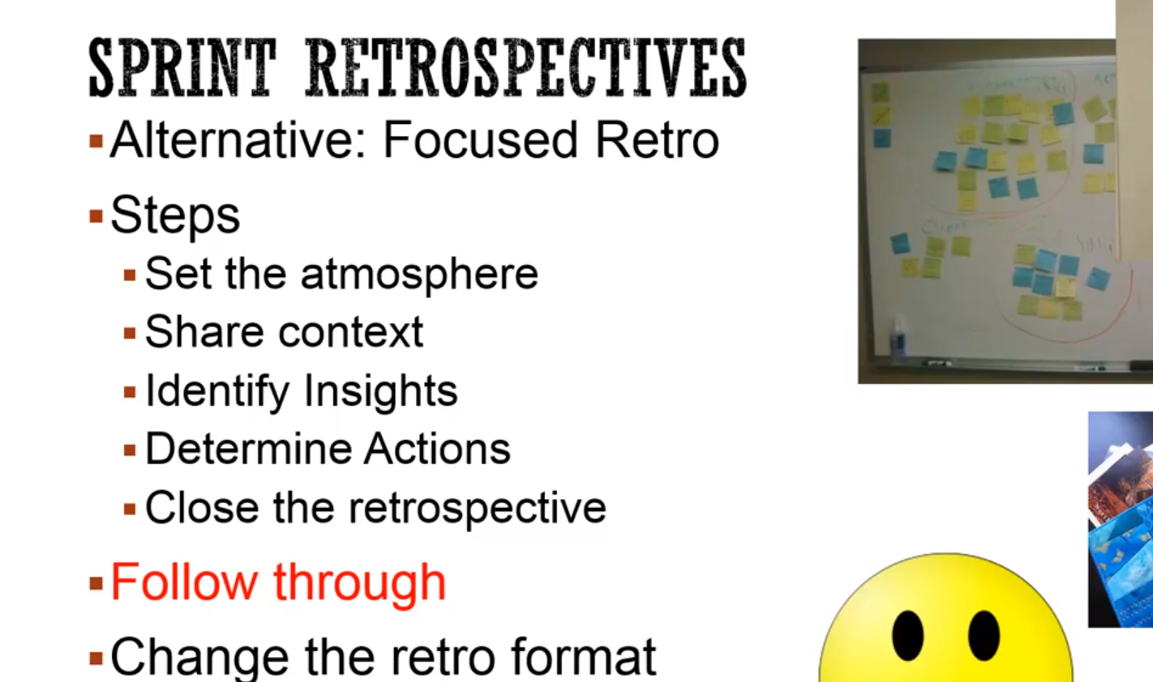

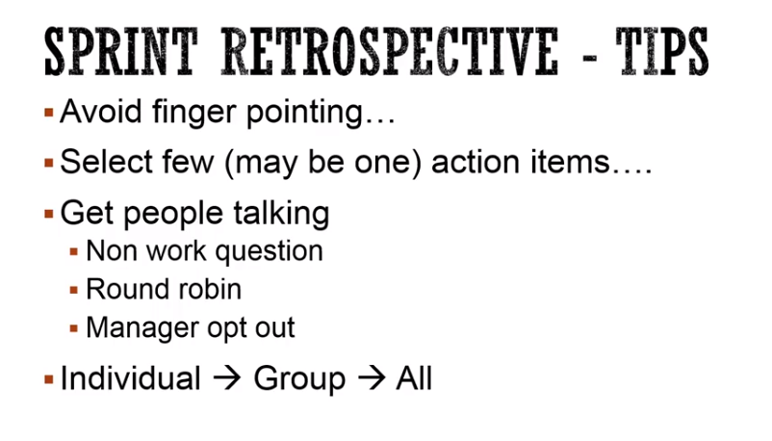

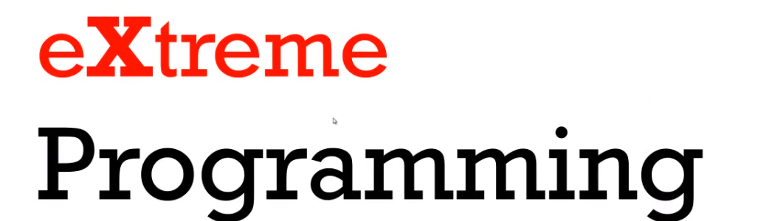

Something good

\

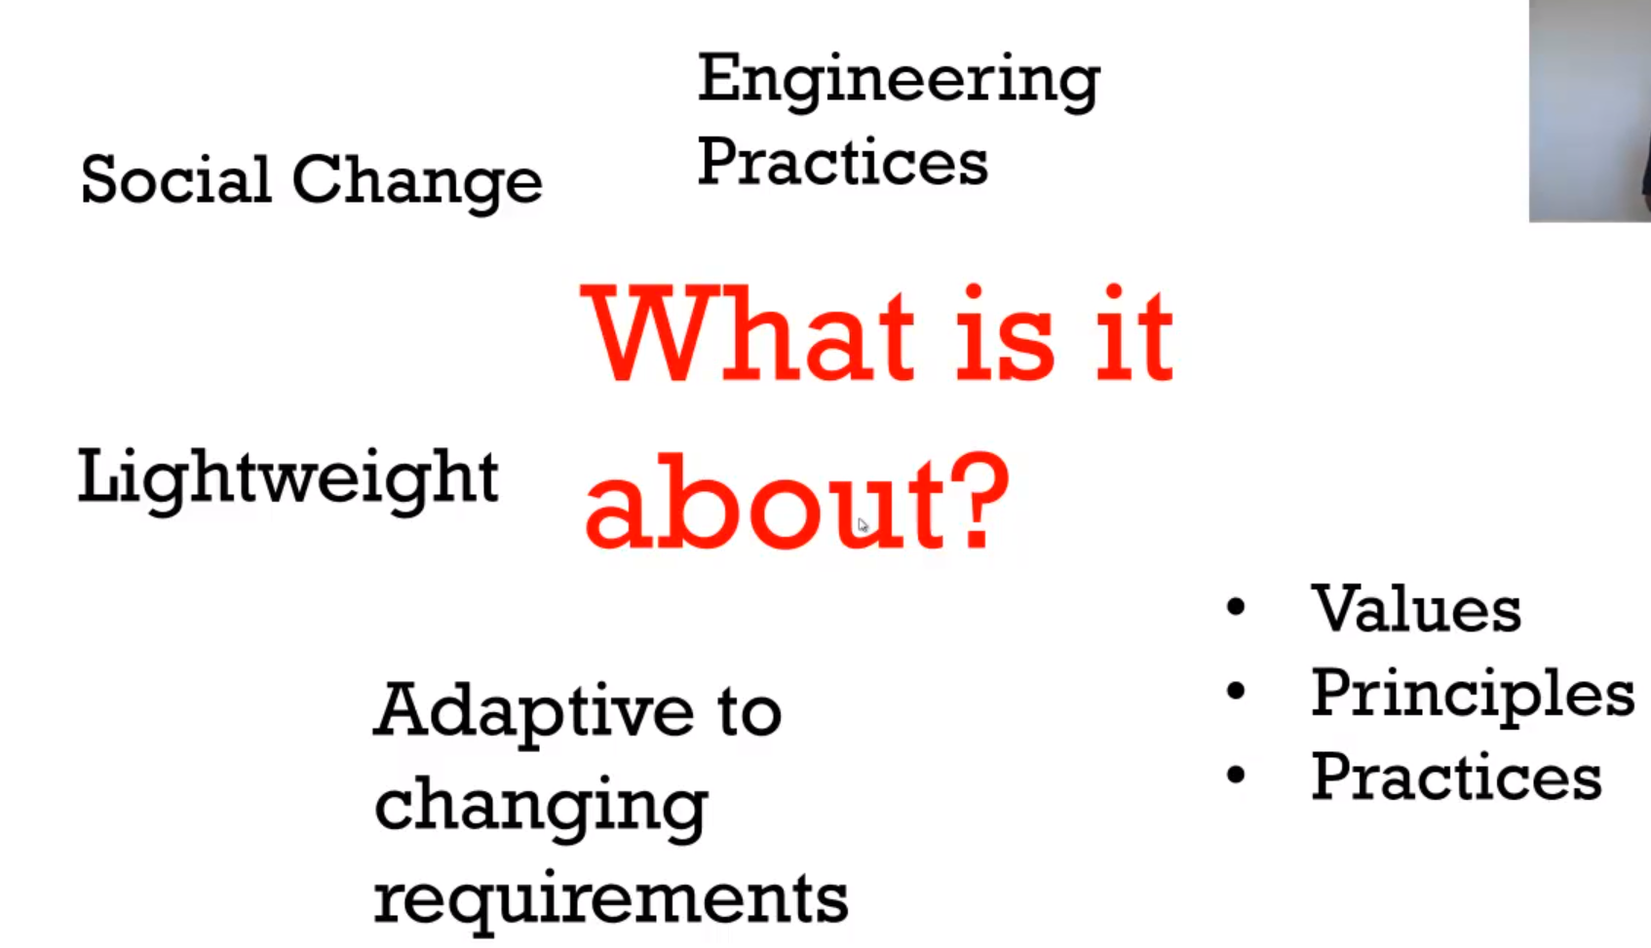

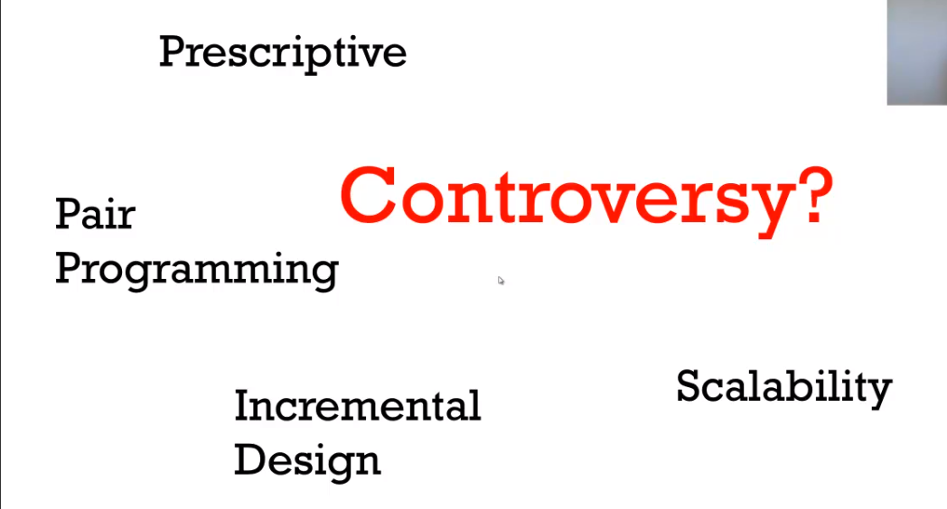

. It's about giving up old habits of working for new ways tailored to the new reality. And it is also lightweight compared to some of the traditional methodologies like Waterfall, etc.

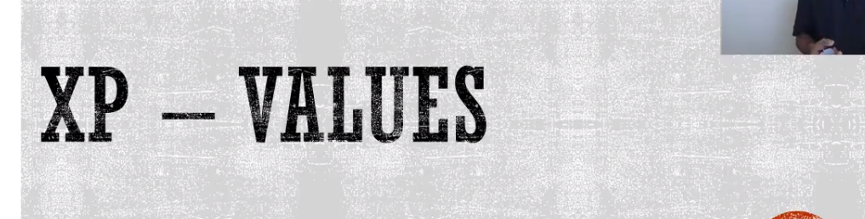

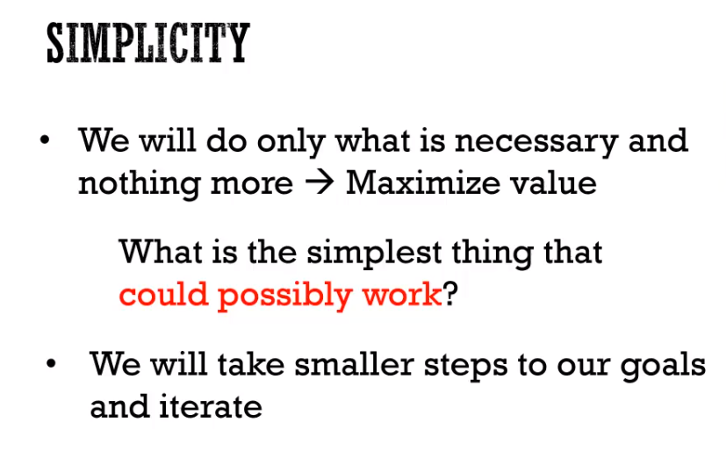

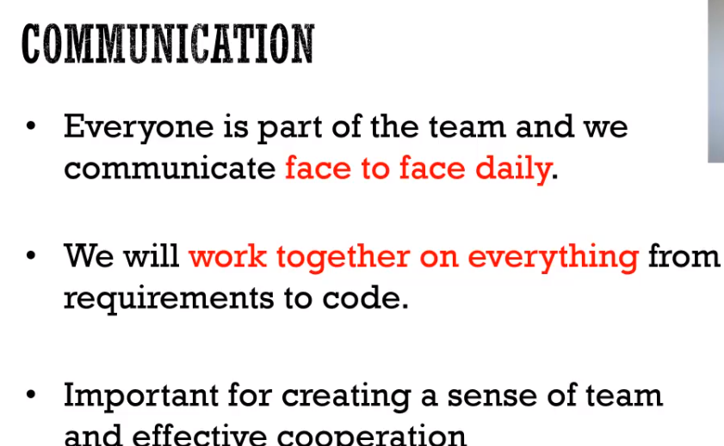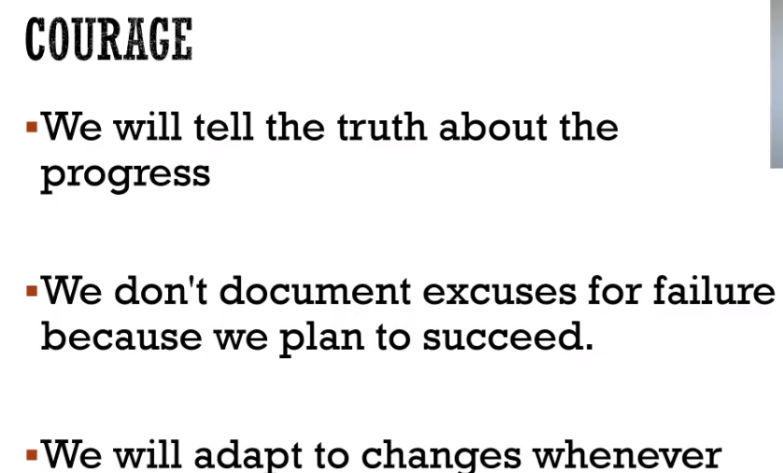

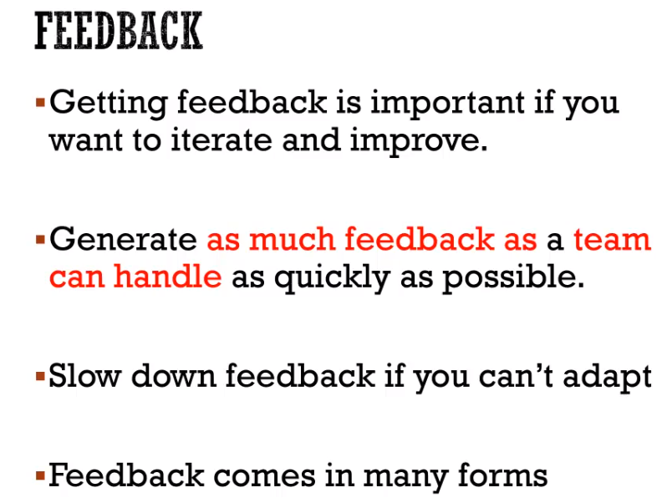

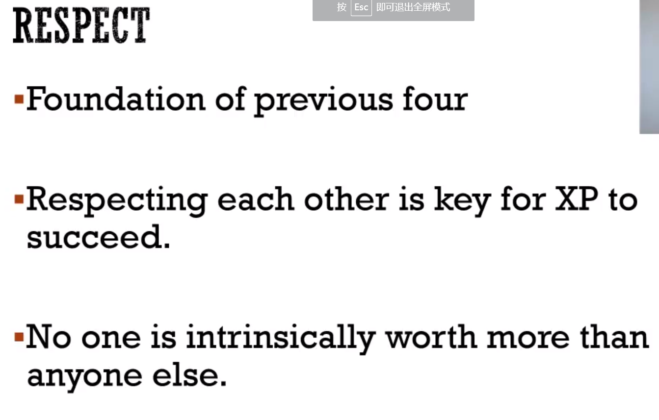

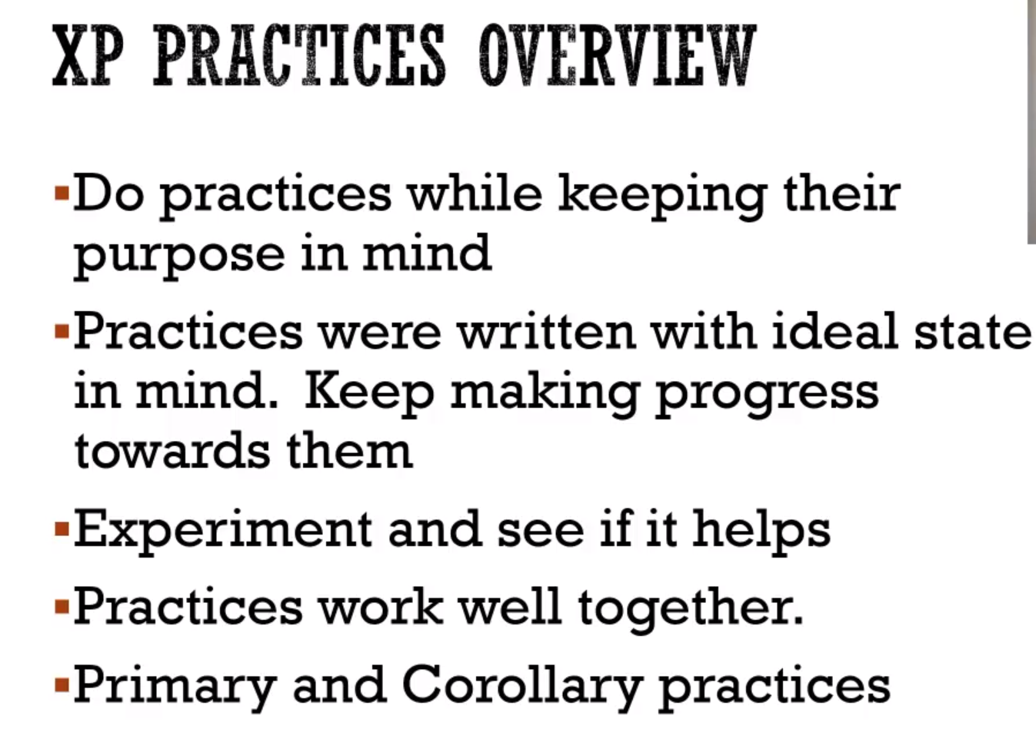

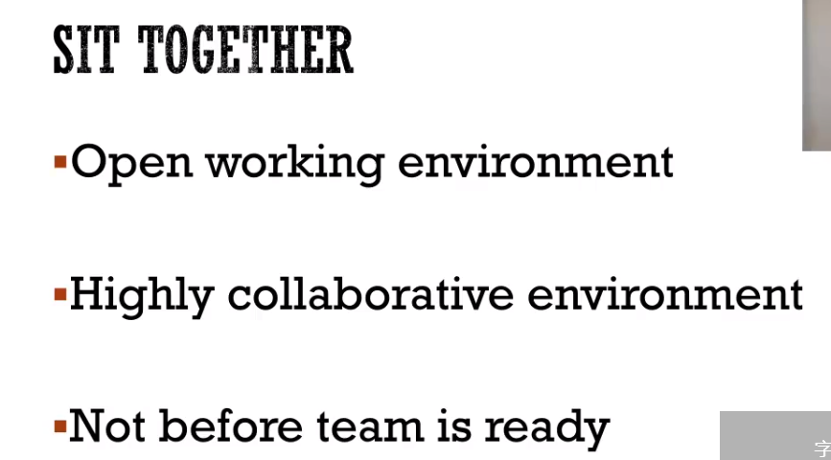

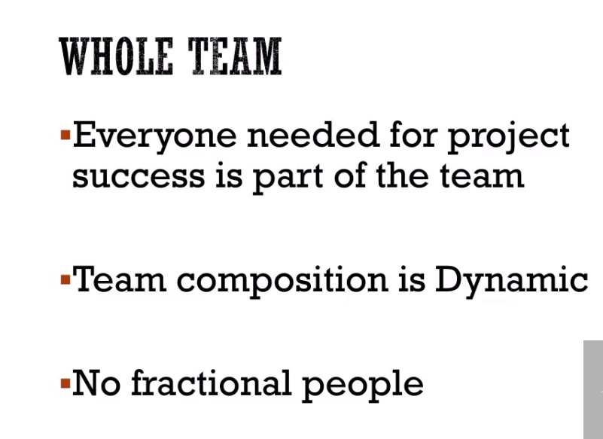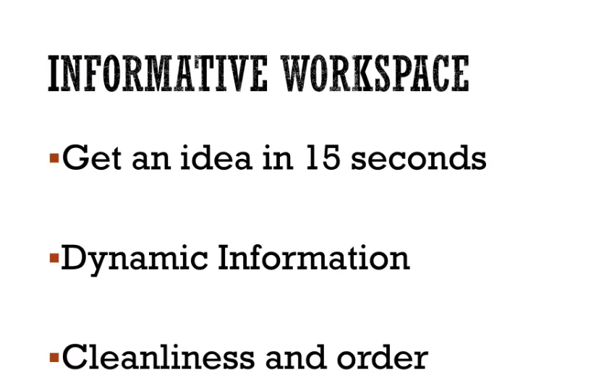

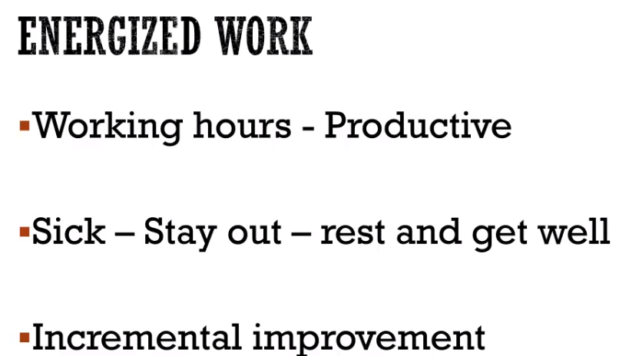

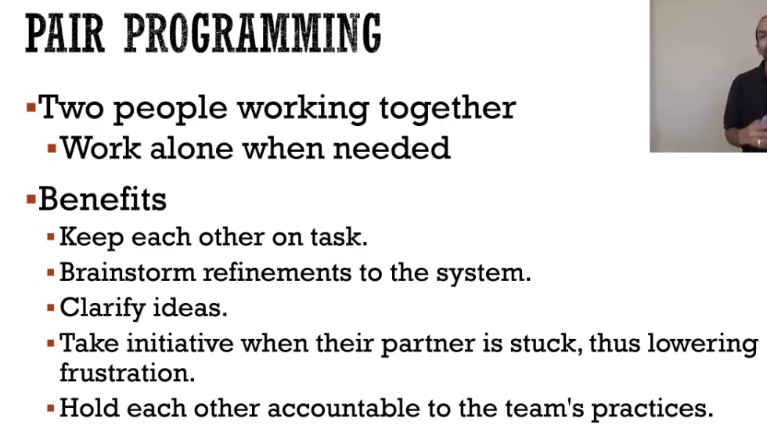

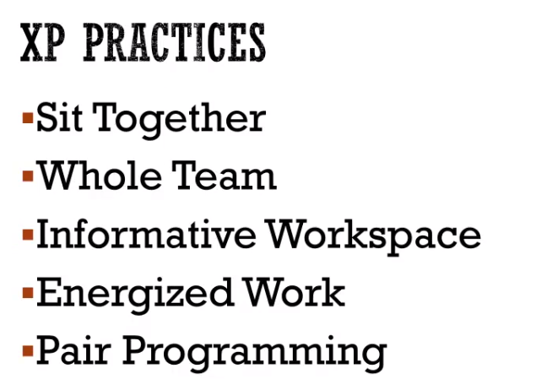

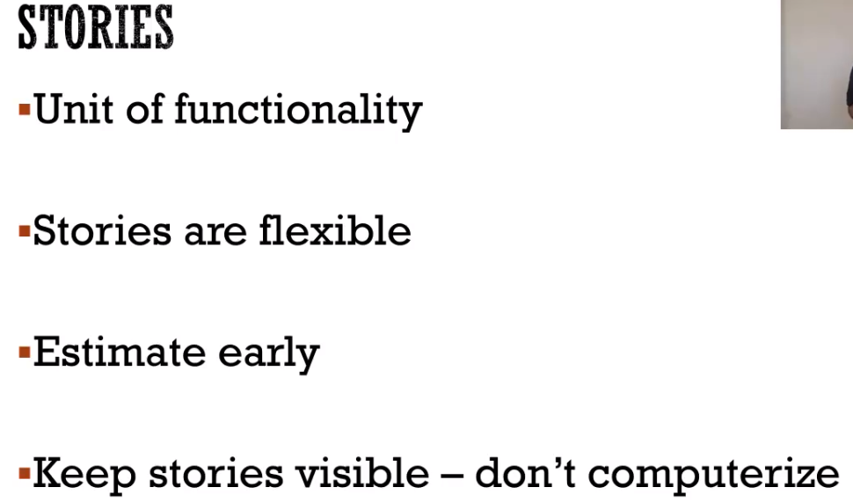

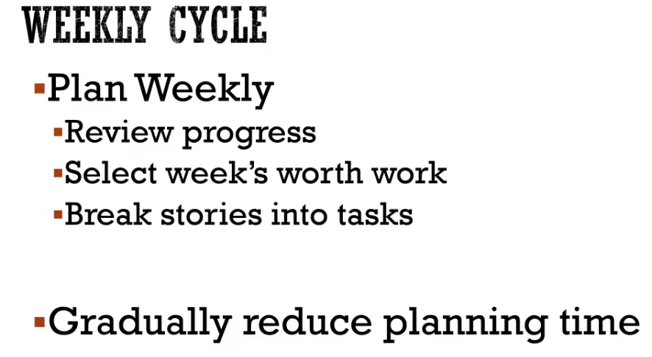

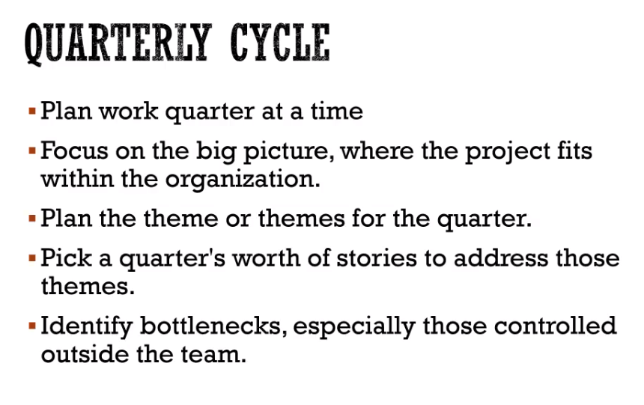

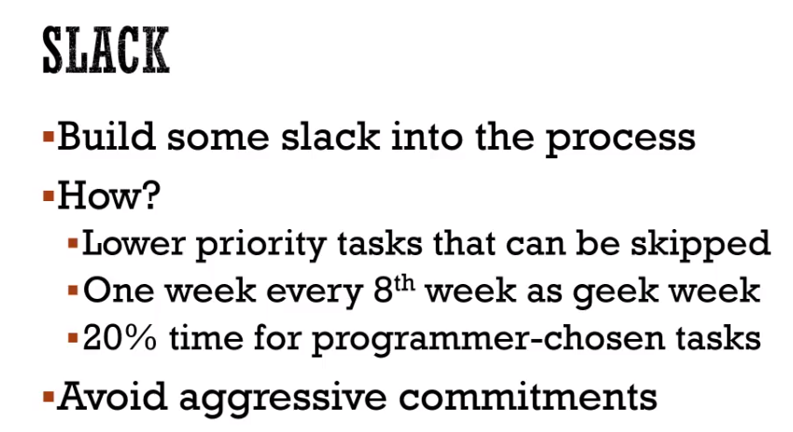

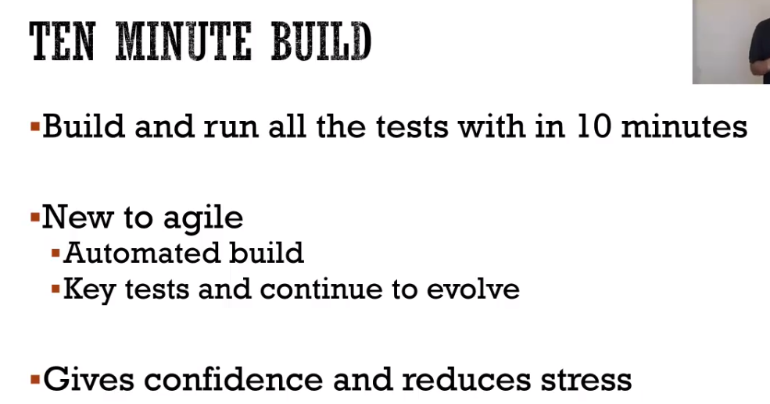

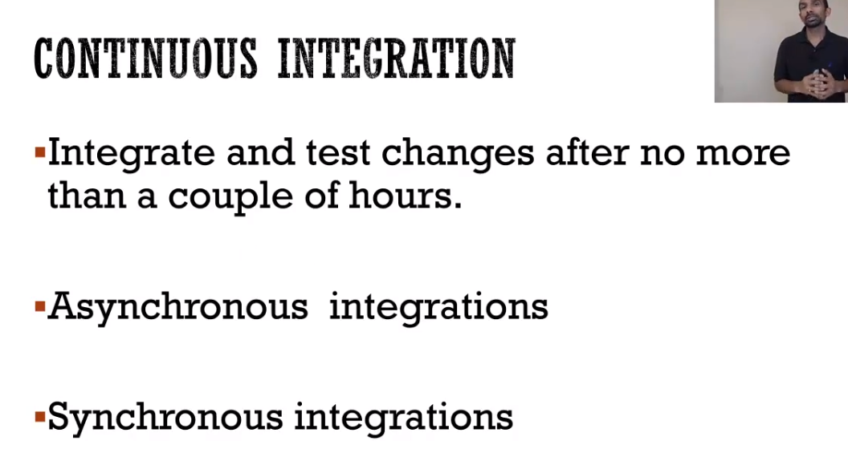

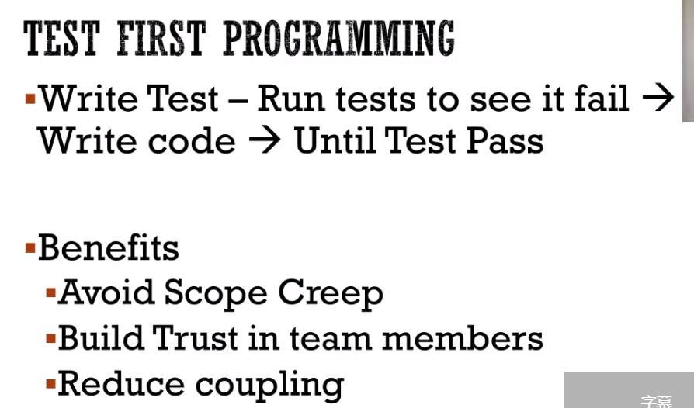

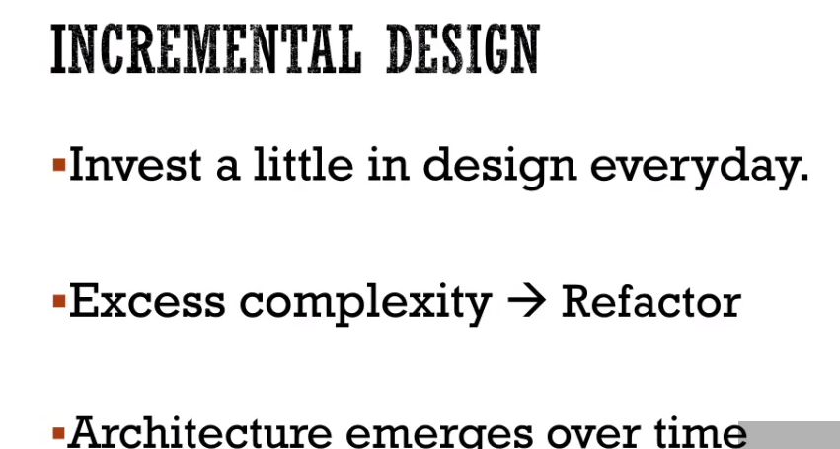

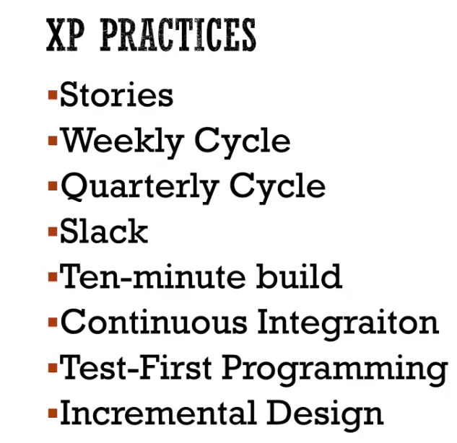

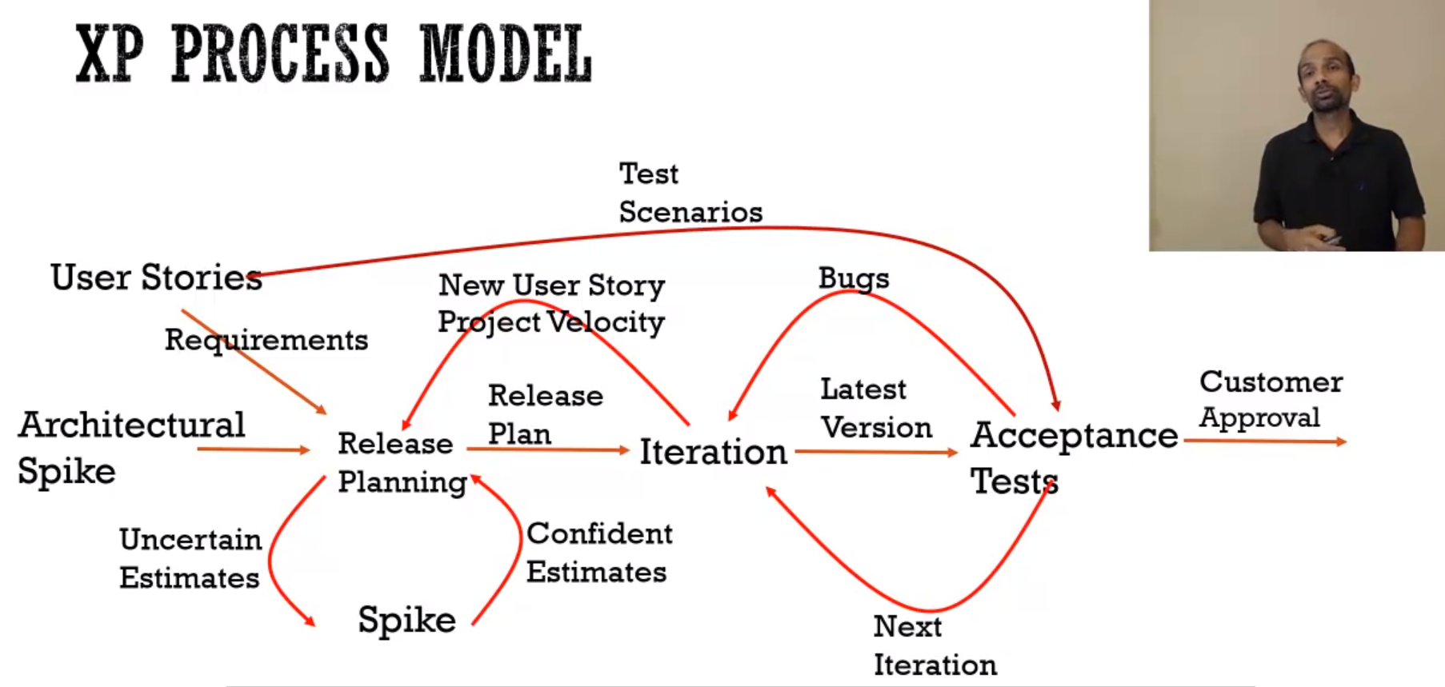

 four main differences between [Scrum](https://www.mountaingoatsoftware.com/agile/scrum) and XP:

1. Scrum teams typically work in iterations (called sprints) that are from two weeks to one month long. XP teams typically work in iterations that are one or two weeks long.
2. Scrum teams do not allow changes into their sprints. Once the sprint planning meeting is completed and a commitment made to delivering a set of product backlog items, that set of items remains unchanged through the end of the sprint. XP teams are much more amenable to change within their iterations. As long as the team hasn’t started work on a particular feature, a new feature of equivalent size can be swapped into the XP team’s iteration in exchange for the unstarted feature.
3. Extreme Programming teams work in a strict priority order. Features to be developed are prioritized by the customer (Scrum’s [Product Owner](https://www.mountaingoatsoftware.com/agile/scrum/roles/product-owner)) and the team is required to work on them in that order. By contrast, the Scrum product owner prioritizes the product backlog but the team determines the sequence in which they will develop the backlog items. I’ve never seen a Scrum team not choose to work on the highest-priority item. And a Scrum team will very likely choose to work on the second most important. However, at some point one of the high priority items may not be a good fit for the sprint being planned—maybe a key person who should work on it will be swamped by work on higher priority items. Or maybe it makes sense to work on a slightly lower priority item (let’s say #10 on the product backlog instead of #6) because the team will be working in the code where #10 would be implemented.
4. Scrum doesn’t prescribe any engineering practices; XP does. I love the XP engineering practices, particularly things like test-driven development, the focus on automated testing, pair programming, simple design, refactoring, and so on. However, I think it’s a mistake to say to the team “you're self-organizing, we trust you, but you **must** do these specific engineering practices....” This sends a mixed message to the team that causes confusion. I love the XP practices but don’t like mandating them. I want teams to discover the value on their own.

These are small and often subtle differences between Scrum and XP. However, they can have a profound impact on the team. My typical advice to teams is “start with Scrum and then invent your own version of XP.” The XP practices are wonderful but they work best and teams commit to them the most stridently if they discover them themselves rather than having them mandated. I help teams do this in my coaching by asking questions like, “Would this bug have happened if we'd been doing test-driven development?” and “Would we have made that mistake if we were pairing?” I find true XP to be a small target off in the distance. If a team can aim at that and hit the bull’s eye, wonderful. If not, however, they are likely hacking (e.g., refactoring without any automated testing or TDD). Scrum is a big bull’s eye that on its own brings big improvements simply through the additional focus and the timeboxed iterations. That’s a good starting point for then adding the XP practices.